|  |  |  |  |
| --- | --- | --- | --- |
| Description: Description: S:\AdminShared\All Staff\1 College Logo's\Baldivis_Logo_colour.jpgName: | \_\_\_\_\_\_\_\_\_\_\_\_\_\_\_\_\_\_\_\_\_\_\_\_\_\_\_\_\_\_\_\_\_\_\_\_\_\_\_\_\_\_\_\_\_\_\_\_\_\_\_ | | Date: *\_\_\_\_\_\_\_\_\_\_\_* |
|  | **Year 11 Applications**  **Test 4, 2020**  **Topics – Pythagoras, Measurement, Similarity and Matirices** | | 43  = % |
| **Total Time:** | *44 minutes* |  | |
| **Total Reading:** | *3**minutes* |
| **Total Working:** | *43 minutes* |
| **Equipment:** | *SCSA Formula Sheet; 1 page notes (A4 two sides,* ***Unfolded****), CASIO ClassPad; Scientific Calculator* | | |

**Resource Free Section – 13 min 1 min reading time [13 marks]**

**1. [3 marks]**

Show how the volume of this sphere can be expressed as 36πcm3

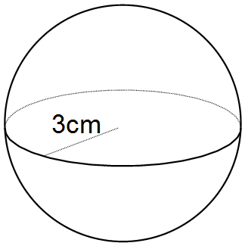

**2. [1, 1, 3, 1, 1, 1, 2 = 10 marks]**

Consider the matrices A= B= C= D=

1. State
2. the size of the row matrix
$d_{12}$

3. Find  and  if 2C
4. If possible, calculate the following. If not possible, explain why.

(i) A + D

1. 2A
2. B – C
3. 3D - A

**Resource Section – 30 min plus 2 min reading time [30 marks]**

**3. [3 marks]**

Find the capacity of the drinking glass pictured below to the nearest ml.

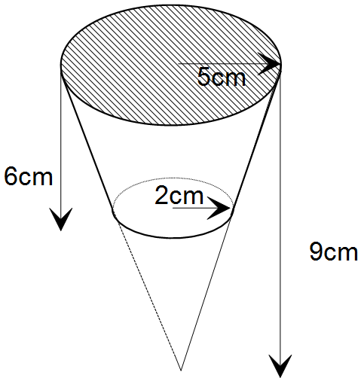

**4. [3 marks]**

What is the longest pencil that can fit into a 4cm cube?

**5. [2 marks]**

Determine the perimeter of the sector shown below.

137°

15 cm

**6. [1, 2, 2 = 5 Marks]**

Swimming’s Cool is a company which produces swimming pools. They have three different models of pool which they sell and each one requires a different amount of each of the following materials as shown in matrix **A** below.

Fiberglass Concrete Tiles Gravel

(Sheets) (kg) (number) (bags)

Model A

Model B

Model C

$\left[\begin{matrix}1 & 100 & 30 & 20 \\ 3 & 120 & 90 & 90 \\ 2 & 150 & 50 & 70\end{matrix}\right]$

**A** =

a) Swimming’s Cool receives the following orders: 4 of Model A, 2 of Model B and 1 of Model C. Create matrix **B** to represent this information.

b) Use matrix methods to calculate the total amount of each material needed to fill the order.

c) The costs for each of the materials are as follows:

Fiberglass Concrete Tiles Gravel

($300/Sheet) ($50/kg) ($5 each) ($70/bag)

Calculate, **using matrix methods and showing full working**, the total cost of the order.

**7. [3, 4 = 7 Marks]**

a) The figures below are similar.



The surface area of the smaller cylinder is 25 mm2. What is the surface area of the larger cylinder?

b) The prisms below are similar.

The volume of the larger prism is 800 m3. What is the volume of the smaller prism?

**8. [2, 2, 2 = 6 Marks]**

For the following sets of triangles, determine whether they are similar or not, and state the rule used to justify your answer.

a)

****b)

c)

****

**9. [1, 3 = 4 Marks ]**

Cadel is going for a casual Sunday cycle. He cycles 20 km due north and stops to have a coffee at a café. Then he cycles 17 km due west to practice his sprints. He then returns directly back home.

a) Draw a diagram to show Cadel’s cycle path.

b) Calculate his total distance traveled.

* End of Test -